**ASSIGNMENTS ON DIGITAL MARKETING**

NAME : S0WMYA V

DEPARTMENT : B.E COMPUTER SCIENCE AND ENGINEERING

COLLEGE : 8151 DHANALAKSHMI SRINIVASAN INSTITUTE OF TECHNOLOGY

NAANMUDHALVAN COURSE : DIGITAL MARKETING

NM ID : 5F87B4CCE0BA24DA109425F5BE4EE7D9

**ASSIGNMENT 1**

Create a blog or website using blogspot and word press customize

The theme design and post new article with 500 words.

<https://fabfoodss.blogspot.com/2023/08/importance-of-food-in-our-life.html?m=1>

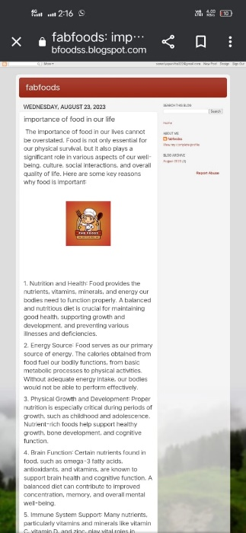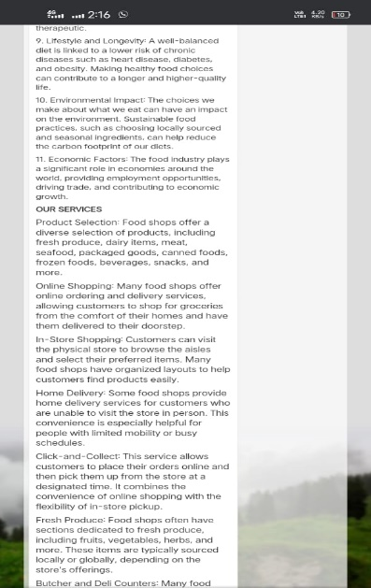

**ASSIGNMENT 2:**

Create a new Facebook business pages and post one social media poster for your brand.

<https://www.facebook.com/sowmya.vedharathinam?mibextid=nW3QTL>

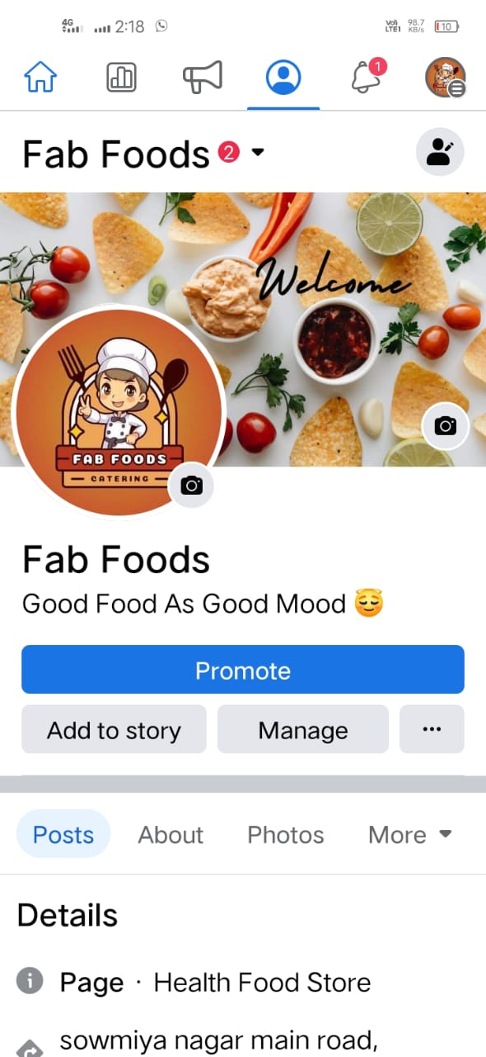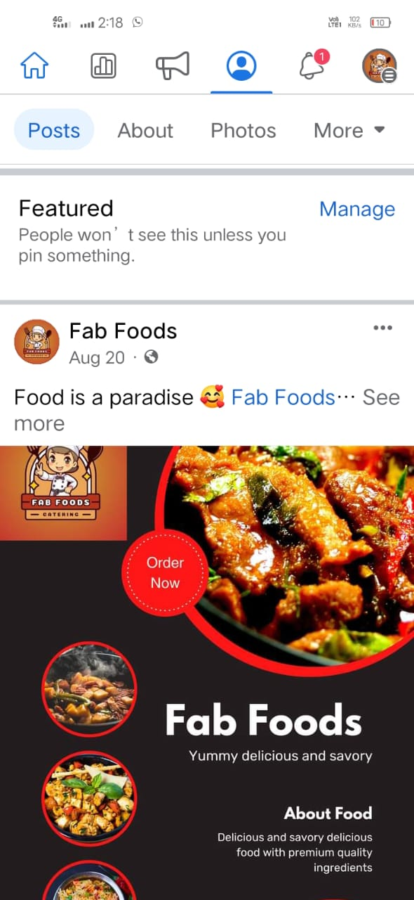

**ASSIGNMENT 3:**

Create and design a social media advertisement poster using Canva.

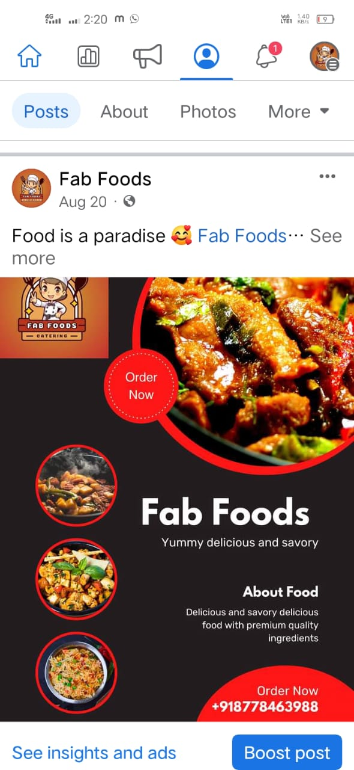

**ASSIGNMENT 4:**

Create Email newsletter design using Mailchimp or Canva tool.

<https://fabfoodss.blogspot.com/2023/08/tales-of-taste-and-structure.html?m=1>

